

Cross Words
Documentation

Supervisor | : | TRAN TRUNG
Curriculum | : | ACCP i7.1
Semester | : | 2 – DISM
Bath Code | : | 0906 – E
 |  | Full Name | Roll No.
Group Members | : | NGUYEN QUOC THAI  NHU QUANG HUY  PHAM HONG TAM  NGUYEN DUY KHANH | Student264488  Student265386  Student267242  Student285103





This is to certify that
Mr.
has successfully designed and
developed

Submitted by:
Date of Issue: ________
Authorized Signature: ___________
Nguyen Quoc Thai

Nhu Quang Huy
This is to certify that
Mr.
has successfully designed and
developed

Submitted by:
Date of Issue: ________
Authorized Signature: ___________
Nhu Quang Huy

Pham Hong Tam
This is to certify that
Mr.
has successfully designed and
developed

Submitted by:
Date of Issue: ________
Authorized Signature: ___________
Pham Hong Tam

Nguyen Duy Khanh
This is to certify that
Mr.
has successfully designed and
developed

Submitted by:
Date of Issue: ________
Authorized Signature: ___________
Nguyen Duy Khanh

Contents

Acknowledgements 9
1. Introduction 10
2. Project Analysis 11
2.1. Customer Requirement Specification 11
2.2. Proposed Solution 12
2.3. Hardware / Software Requirements 12
2.3.1. Hardware 12
2.3.2. Software 13
2.4. Project Plan 13
3. Project Design 14
3.1. Database Design 14
3.1.1. Table “highscore” 14
3.1.2. Table “loginpuzzle” 14
3.1.3. Table “puzzle” 14
3.1.4. Table “question" 15
3.2. E-R Diagrams 15
3.3. Class Object Diagrams 16
3.3.1. High Score 16
3.3.2. Puzzle 16
3.3.3. Question 17
3.3.4. User 17
3.4. Site map 18
3.5. Use Case Diagrams 18
3.5.1. Admin Functionally 18
3.5.2. User Functionally 19
3.6. Flowchart Diagrams 20
3.6.1. Admin Login 20
3.6.2. Admin Logout 21
3.6.3. Create Puzzle 22
3.6.4. Delete Puzzle 23
3.6.5. Attempt the puzzle 24
3.6.6. View High Score 25
3.7. Data Diagrams 26
3.7.1. Login Admin 26
3.7.2. Log out Admin 26
3.7.3. Create Puzzle 27
3.7.4. Delete Puzzle 27
3.7.5. Attempt the puzzle 28
3.7.6. View High Score 28
3.8. Graphic User Interface 29
3.8.1. Main Form 29
3.8.2. Login Form 29
3.8.3. Control Admin Form 30
3.8.4. Create Puzzle Form 30
3.8.5. List Puzzle Form 31
3.8.6. Play Puzzle Form 32
3.9. Task Sheet 33
4. User’s Guide 34
4.1. Figure 1 : Create a new game 34
4.2. Figure 2 : Play game 37
5. Developer’s Guide 39
5.1. Source code installation 39
5.2. Configuring MS SQL Server 2005 39
5.3. Database Installation 42

Acknowledgements
We would like to acknowledge Mr.Tran Trung’s service who guided us this project to success and also like to express our gratitude to all the staff members of my center.
We wish to express our gratitude to the eProject team at the Head Office, who guided and helped us.
Finally, we would like to offer many thanks to all our colleagues for their valuable suggestions and constructive feedback.
Team.

Introduction
Our client, Mr. Luther is the owner of a website “Luther.com”. He is a mathematician by profession. He is working in one of the famous institutions situated at a location near by his residence. He generally uses this website for the purpose of displaying his work, or he conducts some exercise, and as well some of the ad words he has subscribed for. He also conducts various quiz related to mathematics for the sake of entertainment to the users of the website. This quiz can be attempted by any of the users who generally visit his website.
Recently he has visited a site, in which he came across a puzzle called “Cross Words”. And he felt it interesting. And thought it would be better if this can be implemented in his website. So he has approached us, so that we can help him by developing a desktop application for conducting this puzzle, so that he can upload it on his site, so that the users can play this puzzle.

Project Analysis

Customer Requirement Specification
Our client, Mr. Luther wants the following actions to be implemented.
- The application should be able to hold a list (at least 2 4X4 puzzles and 2 6X6 puzzles are to be developed with the questions and the answers)
- You must develop two such tables, one with “4X4”, and the other with “6X6”.(i.e., the table with 4 rows and 4 columns (or) 6 rows and 6 columns).
- Each cell should only contain one character, i.e., the size of the cell of the table should be in such a way that only one character is to be accepted. If the user enters more than one character, then a dialog box is to be displayed stating that only one character is to be entered.
- The puzzles are to be stored with the unique id, so that the questions of that puzzle will be stored with reference to that puzzle id.
- The questions and the answers of the puzzles should be stored with reference to the puzzle id.
- The answers are to be stored with reference to both the question id and the puzzle id.
- As soon as a user starts playing the puzzle, the timer is to begun, and should count the time period for which the user has played the puzzle. i.e., at the end the user should be able to view the time taken by him/her for attempting the puzzle.
- The timer should stop counting the time, as soon as the user clicks on the button “Quit”, or “Submit” button.
- When a user clicks on the submit button, the application should ask for the name of the player, and after the user enters the name, the dialog box is to be displayed stating that he/she has played the puzzle for so and so time. Like for example, if a user “a” has played the puzzle, and submitted or quit the game, then the user is asked to enter his/her details through the dialog box. And in the dialog box, the user has entered his/her name to be “a”, then after entering the name and submitting it, as screen is to be displayed stating that “a” has finished so and so puzzle with the puzzle id, for so and so time.
- The application should be able to store the details of the highest scorer till date.
- The admin, the owner of the site should be able to perform the following functionalities
  - Generate the puzzles, based on the size of the table (4X4 or 6X6), by assigning the questions as per the size of the table and the availability of the cells.
  - For generating the puzzles the admin should be able to store and maintain the questions along with the answers and the size of the answer.
  - Assigning the character “*” to the cells, where the data is not required to be entered.
- The user should have the following functionality:
  - They should be able to attempt the puzzle, by editing the cells that are not filled with the character “*”
  - The users other than the admin, should not be able to edit the cells of the tables, that are filled with the character “*”
  - The users should be only able to edit the cells that are not filled with the character “*”
  - After attempting the puzzle, the user should be able to submit the puzzle.
  - After the submission of the puzzle, the user should be able to view the answers for that puzzle which is attempted.

Proposed Solution
We propound to use MVC (Model-View-Controller) model.
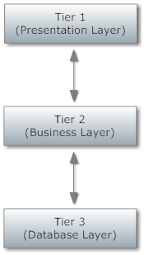

Hardware / Software Requirements

Hardware
- A minimum computer system that will help you access all the tools in the courses is a Pentium 166 or better.
- 64 Megabytes of RAM or better.
- Windows 98 (or higher if possible).
- Java Virtual Machine.

Software
- Notepad / Java Editor (NetBeans, Eclipse, etc).
- JDBC Driver.
- SQL Server 2005.

Project Plan
Number | Task | Start | End | Status | Comment
1 | Frist Report | 12/20/2009 | 12/30/2009 | Done
2 | Code + Report | 12/31/2009 | 1/10/2010 | Done
3 | Final Report + Source Code | 1/11/2010 | 1/20/2010 | Done

Project Design

Database Design

Table “highscore”
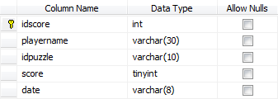
Column Name | Description
idscore | Stored idscore
playername | Stored player name
idpuzzle | Reference idpuzzle from “puzzle” table
score | Stored score for player
date | Stored total time player played it

Table “loginpuzzle”
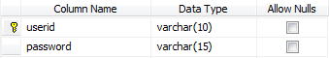
Column Name | Description
userid | Stored user name
password | Stored password

Table “puzzle”
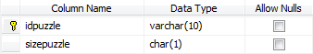
Column Name | Description
idpuzzle | Stored idpuzzle
sizepuzzle | Stored size of puzzle

Table “question"
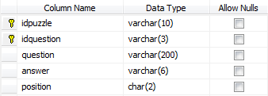
Column Name | Description
idpuzzle | Reference idpuzzle from “puzzle” table
idquestion | Stored idquestion
question | Question
answer | Answer
position | Stored position for answer

E-R Diagrams
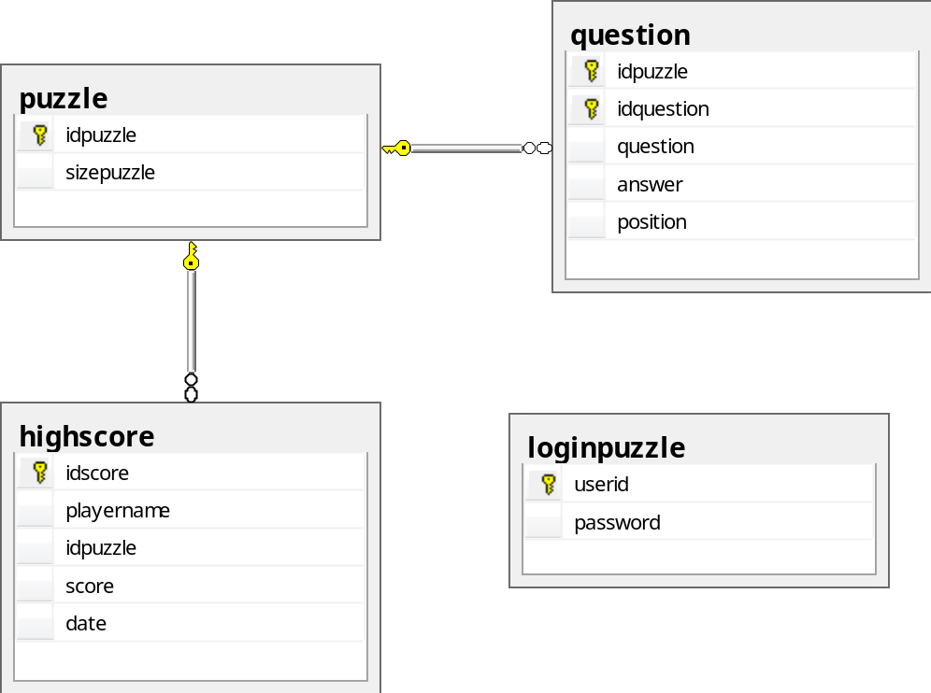z

Class Object Diagrams

High Score
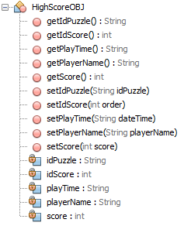

Puzzle
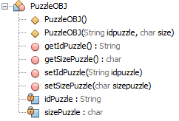

Question
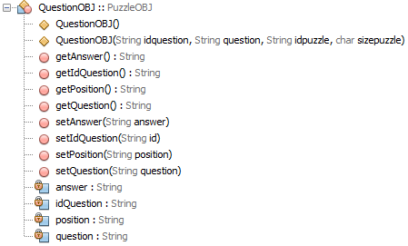

User
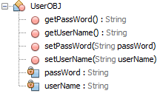

Site map
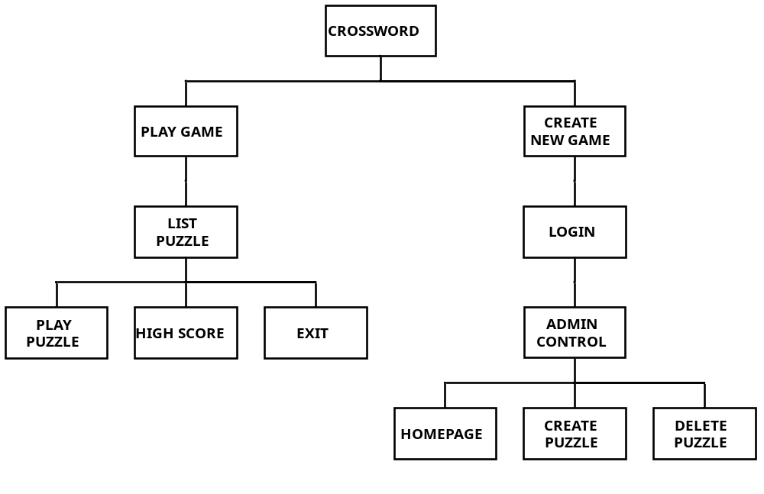

Use Case Diagrams

Admin Functionally
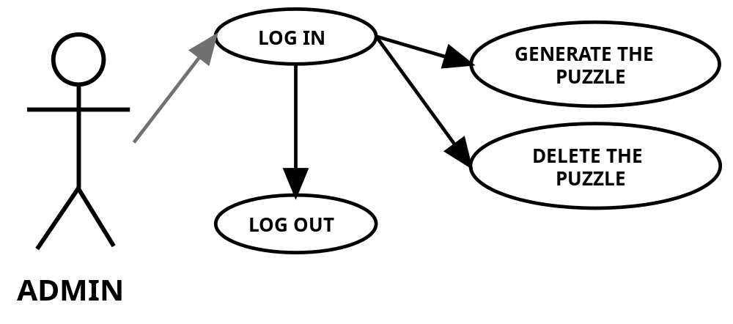

User Functionally
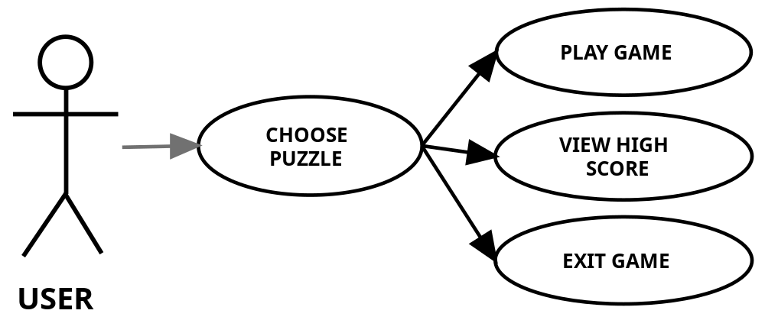

Flowchart Diagrams

Admin Login
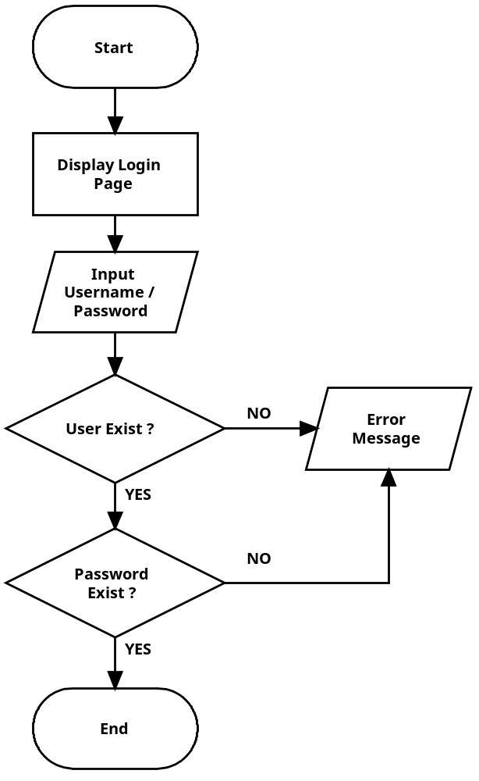

Admin Logout
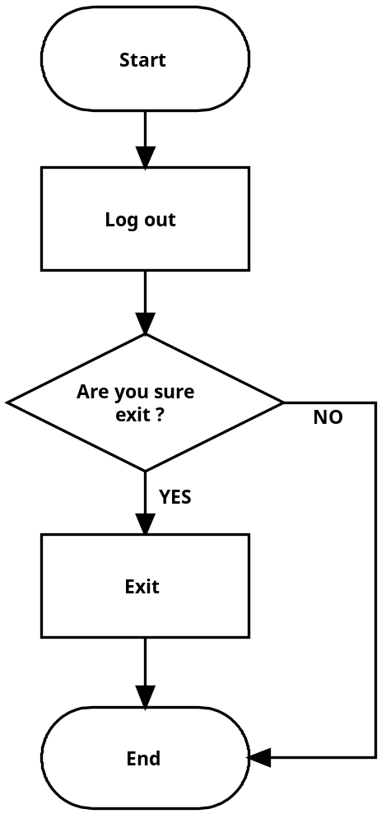

Create Puzzle
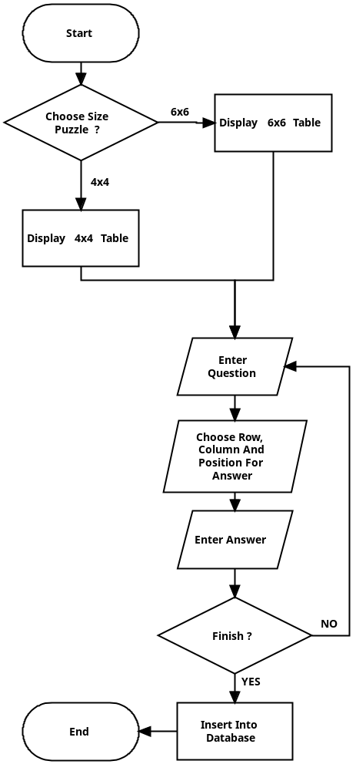

Delete Puzzle
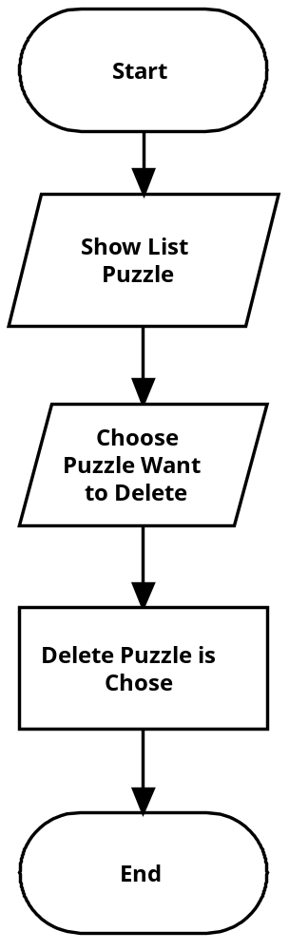

Attempt the puzzle
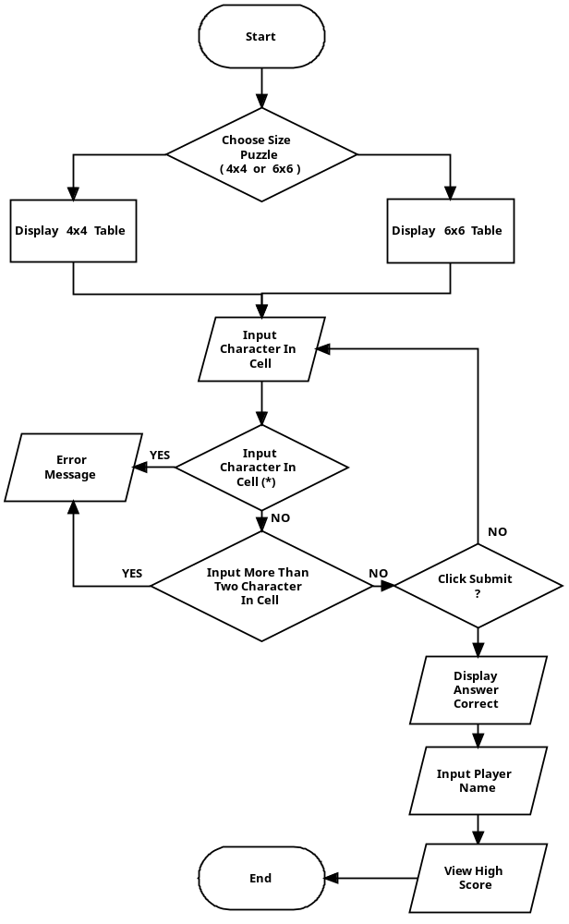

View High Score
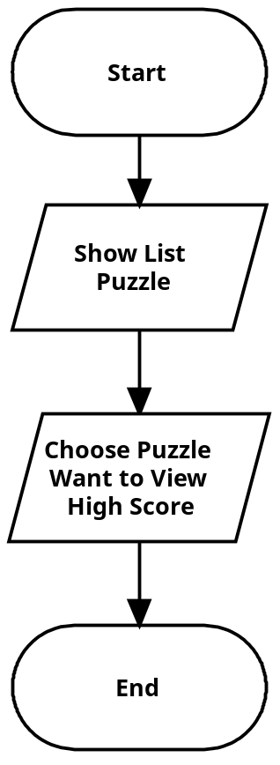

Data Diagrams

Login Admin
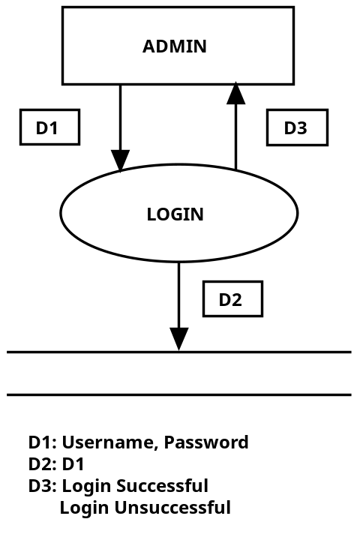

Log out Admin
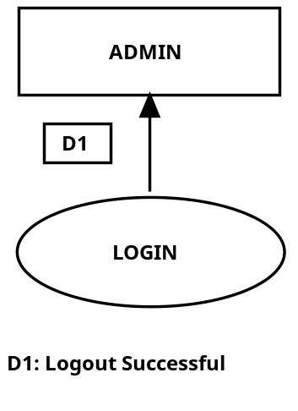

Create Puzzle
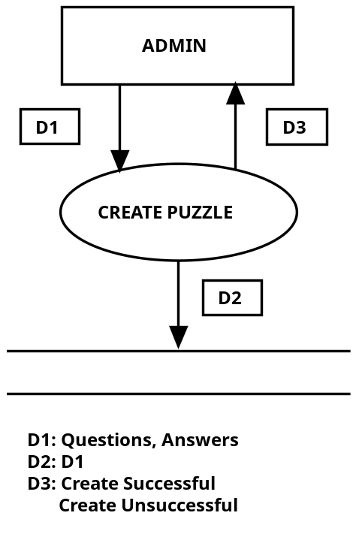

Delete Puzzle
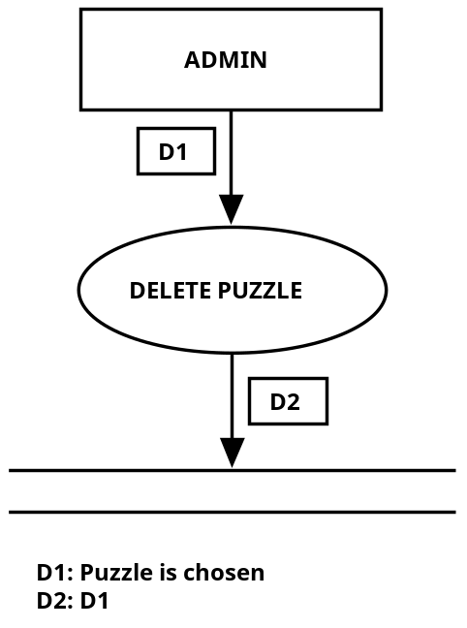

Attempt the puzzle
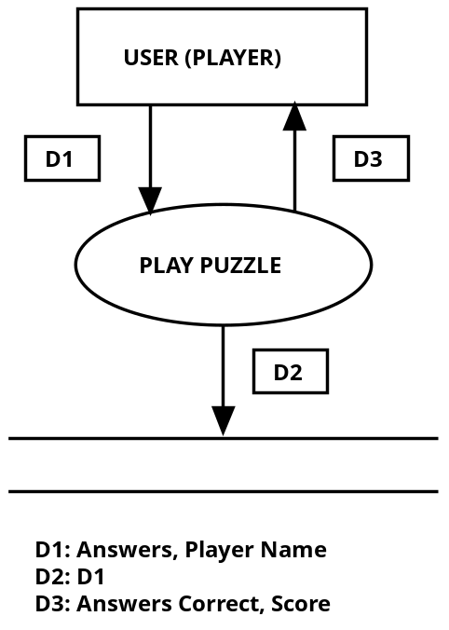

View High Score
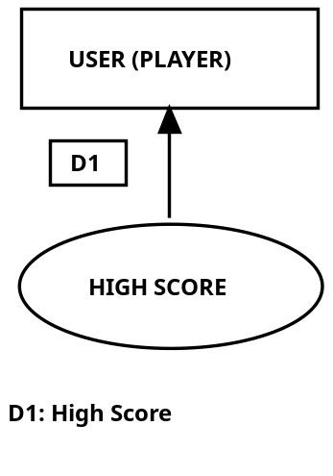

Graphic User Interface

Main Form
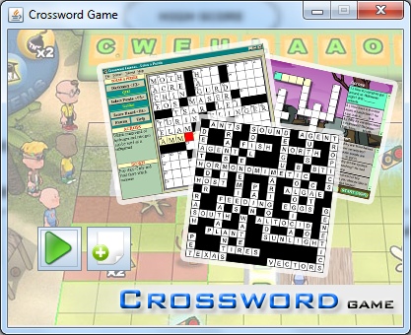

Login Form
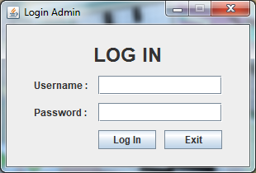

Control Admin Form
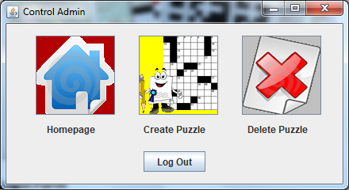

Create Puzzle Form
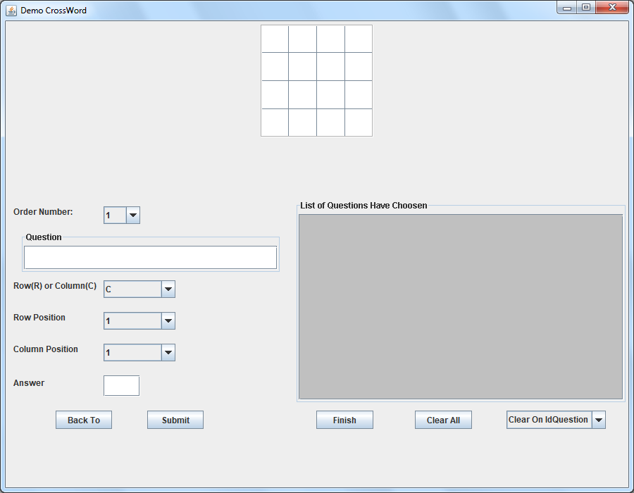

List Puzzle Form
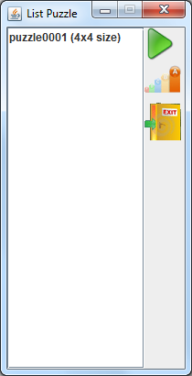

Play Puzzle Form
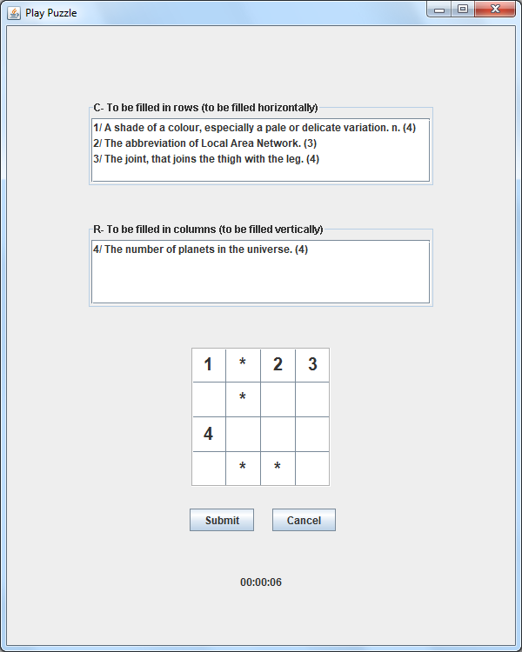

Task Sheet
Project Ref. No.: | Project Title: DIS |  |  | Activity Plan Prepared By: Team |  |  | Date of Preparation of Activity Plan:  12/20/2009
Task Sub division |  | Actual Start Date | Actual Days |  | Team Mate Names | Status
1. Requirements analysis |  | 12/20/2009 | 1 |  | Team | DONE
2. Database Design |  | 12/21/2009 | 3 |  | Team | DONE
3. GUI Design |  | 12/25/2009 |  |  | Team | DONE
4. Code |  | 12/31/2009 |  |  | Team | DONE

User’s Guide

Figure 1 : Create a new game
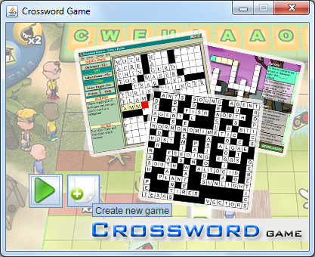
- Click on button “Create new game”.
- Login Admin will show as below. Enter “admin” as Username and “admin” as Password to Login.
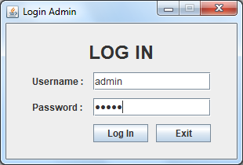
- If login successful, the form below will appear.
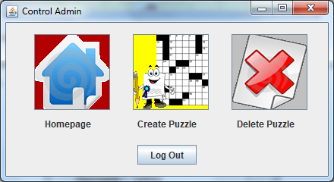
- Choose “Homepage”, if you want to back main form as top.
- Choose “Create Puzzle” to create a new game.
- Choose” Delete Puzzle” to delete puzzle.
- Click on button “Create Puzzle”, another form will appear, you choose 4x4 or 6x6. After that, click on button “Submit”.
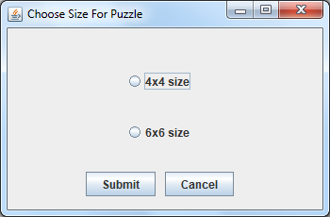
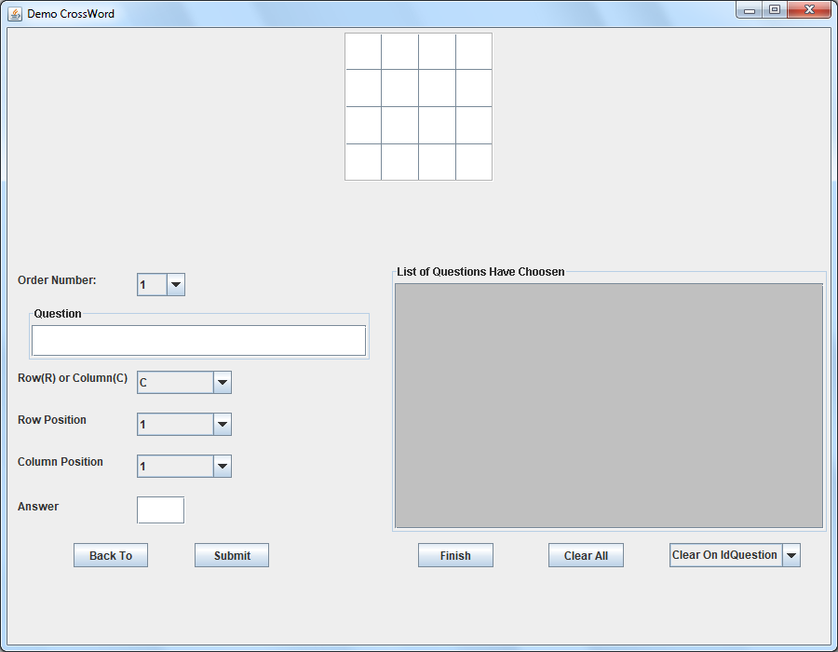
- At this form, you can add the question and the answer you want. One by one question you add, you must click on “Submit” to add that question and answer to the list of the right side. If you finish, just click button “Finish” to add that into database.

Figure 2 : Play game
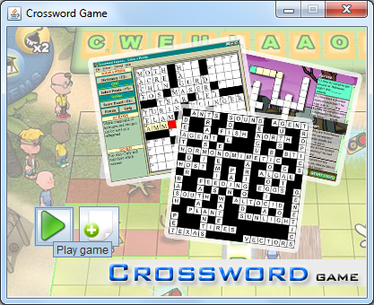
- Click on button follow on this picture.
- The List Puzzle Form will appear.
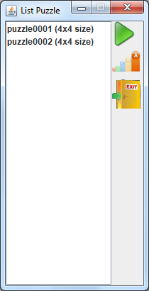
- Choose one puzzle you want to play.
- If you want to view High Score, click on button “High Score”
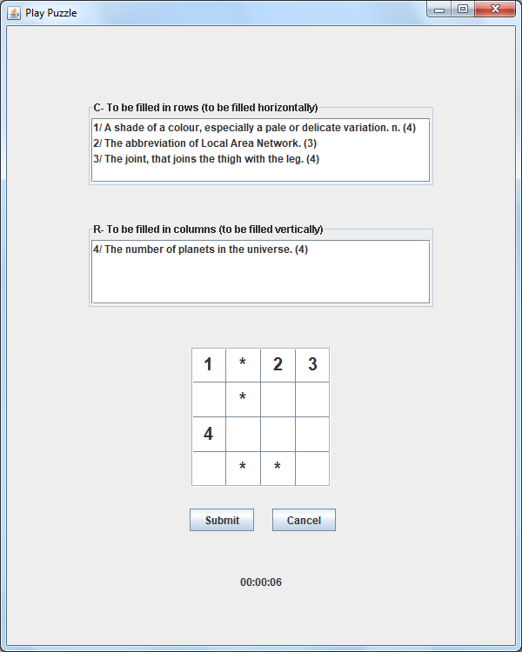

Developer’s Guide

Source code installation
- You can you use Eclipse or Netbeans to view source code. Just import folder src into workspace. Remember, you must add library “sqljdbc4.jar” into project.
- You can config JDBC by edit “DataUtil.java” in util’s package.
- This soure code can use and development.

Configuring MS SQL Server 2005
- Select Start menu - Microsoft SQL Server\Microsoft SQL Server 2005\Configuration Tools\SQL Server Configuration Manager
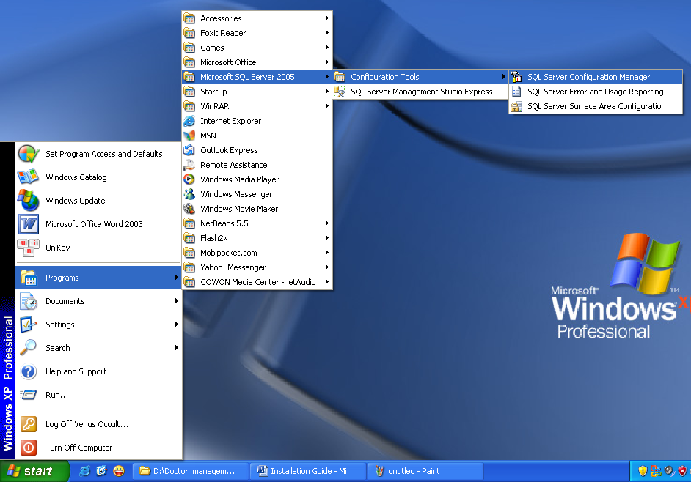
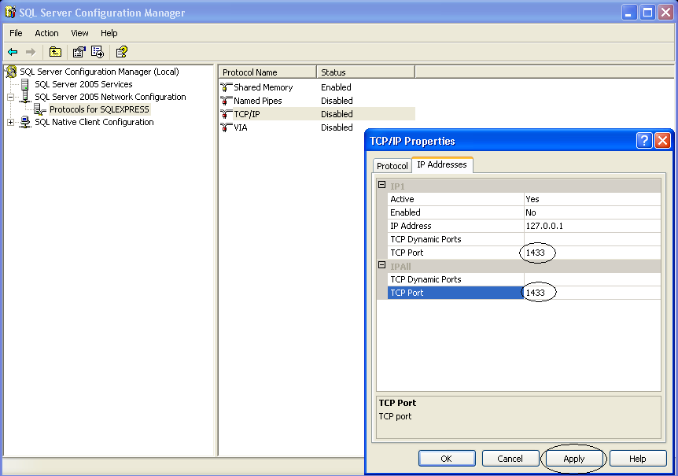
- Enter TCP Port: “1433”.
- -Change Authentication Mode:
- Start MS SQL Server 2005 Start Program \Microsoft SQL Server\Microsoft SQL Server 2005\SQL Server Management Studio
- Right –click on Server Data Engine and choose Properties
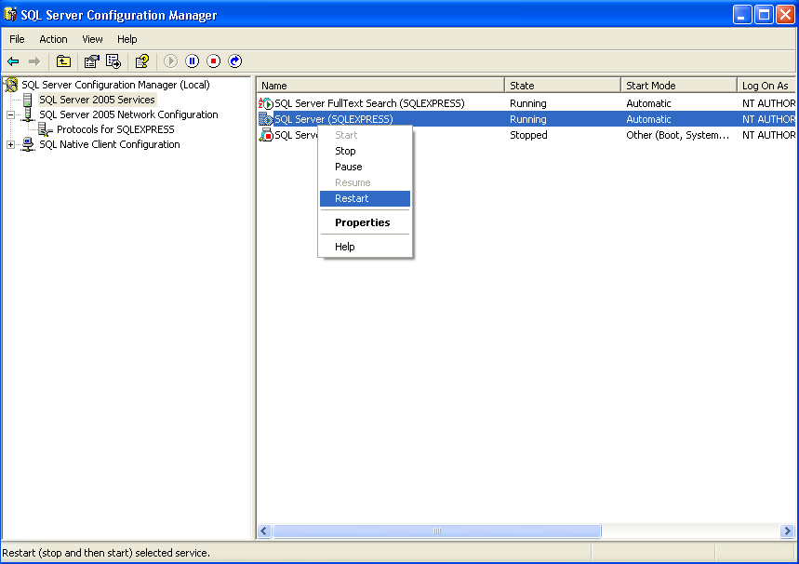
- Next…
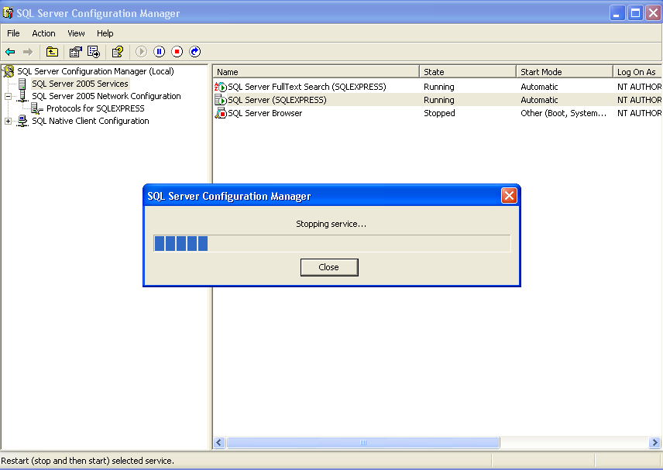
- It’s Ok.

Database Installation
- Just execute “create_Crossword_Database.sql” in SQL Server.

